**HBD Cake**



**Ingredients**

Water 100 g



granulated sugar 300 g

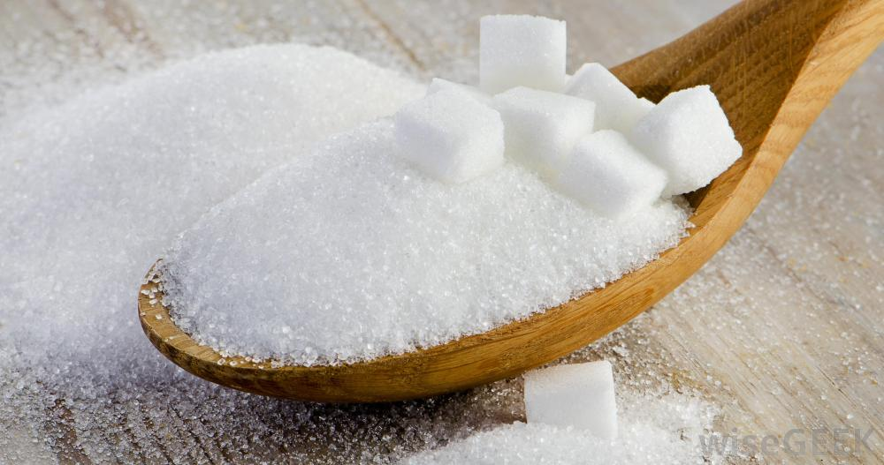

Salt ¼ teaspoon

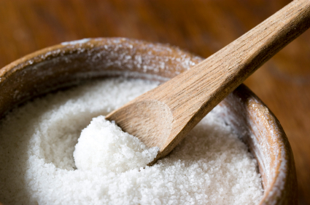

Vanilla Powder ½ teaspoon

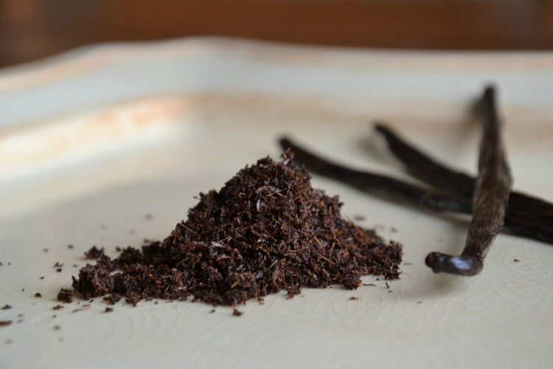

Egg whites 150 g

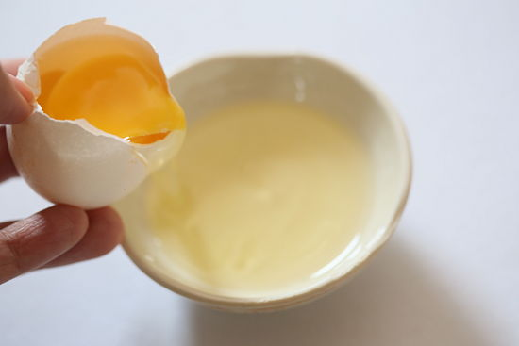

Cream of Tartar ¼ teaspoon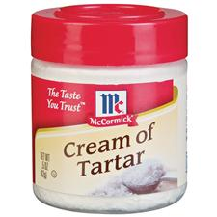

**Five Friends Bread**

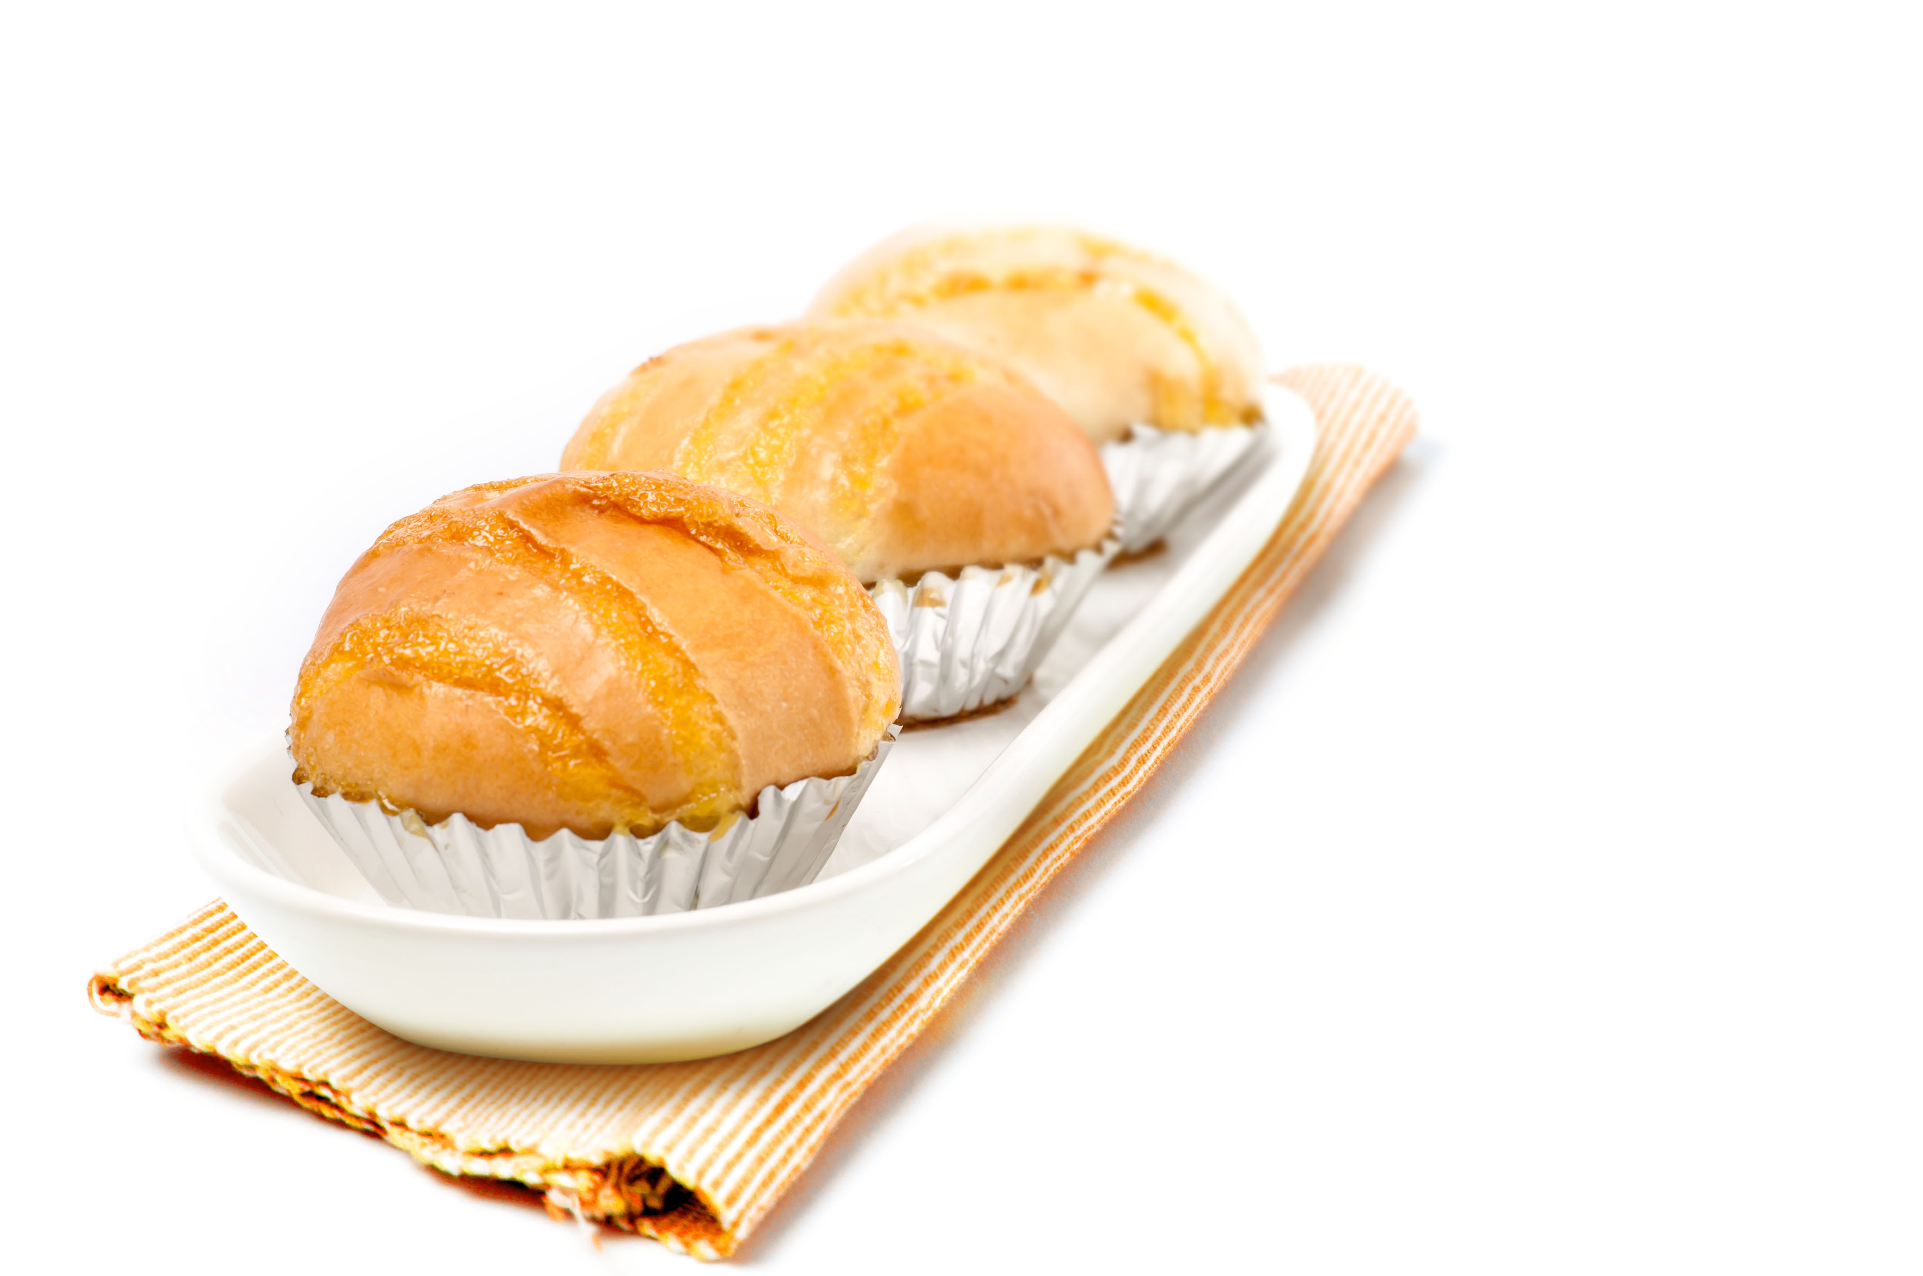

**Ingredients**

Bread flour 500 g

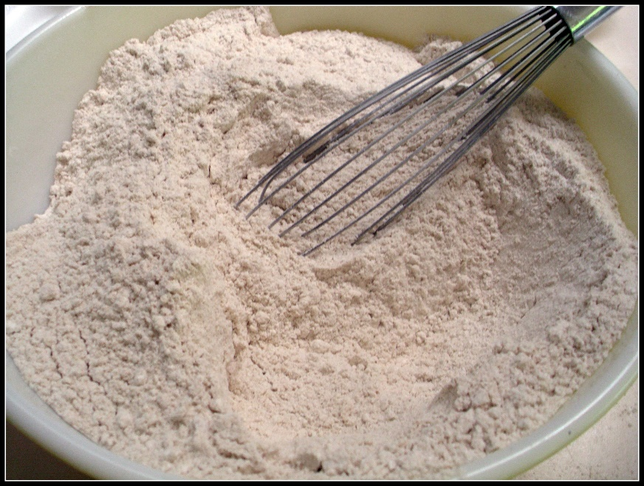

Yeast 10 g

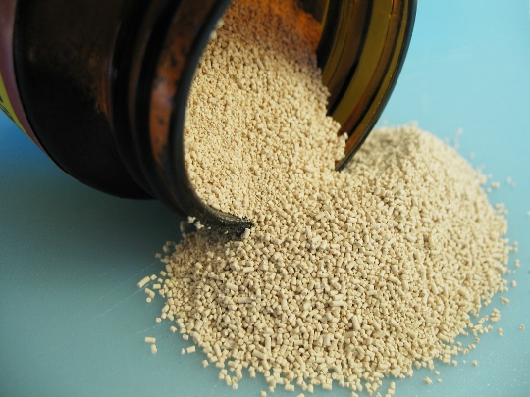

Milk Powder 1 tablespoon

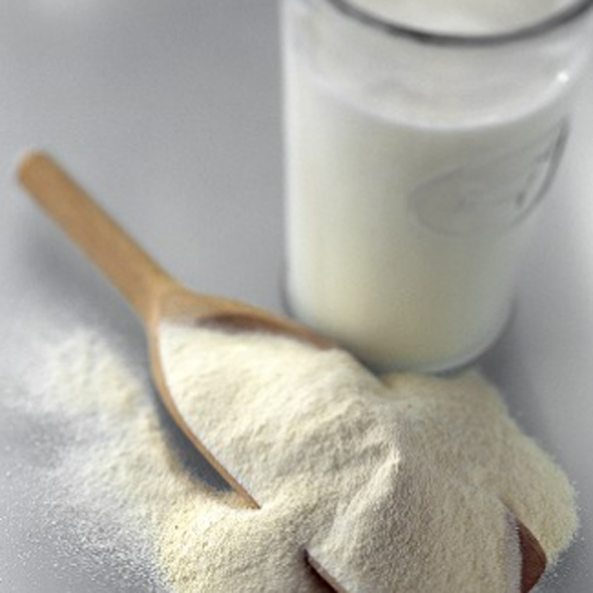

Egg 1 egg

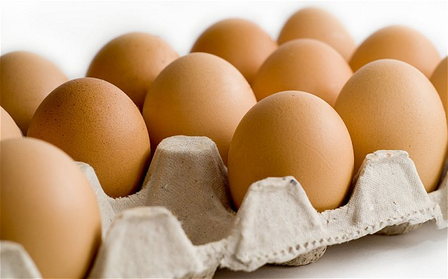

Fresh butter 60 g

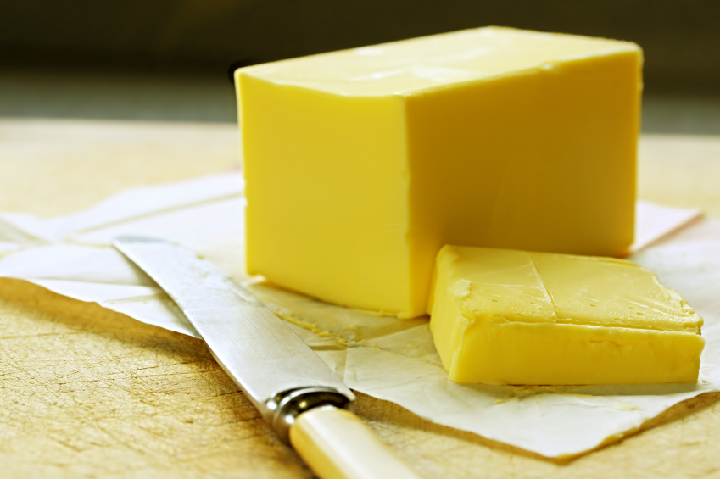

Water 250 g

granulated sugar 60 g

Salt 5 g

**Butter Bread**

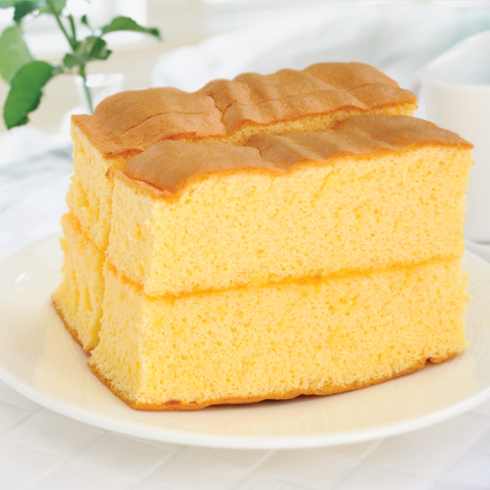

**Ingredients**

Fresh milk 350 g

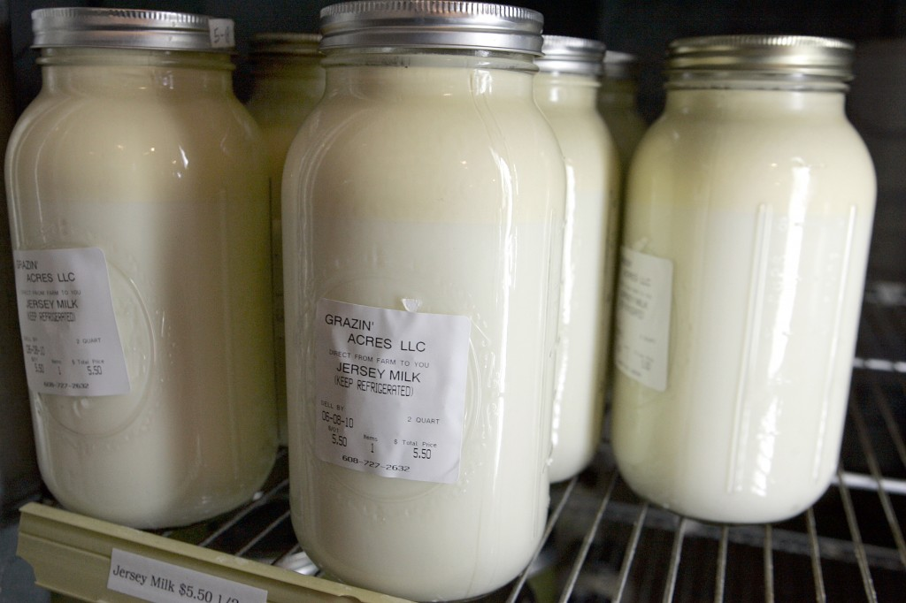

Baking powder 1 teaspoon

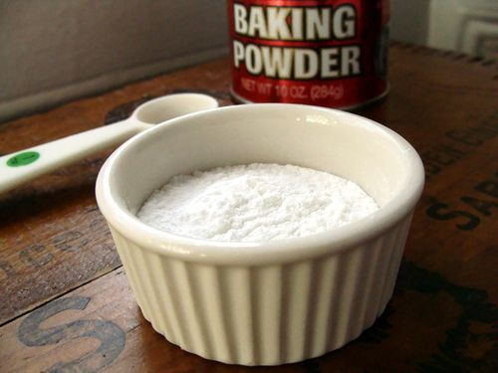

granulated sugar 200 g

Salt 1½ teaspoons

Egg 1 egg

Fresh butter 100 g

Yeast 12 g

Milk Powder 700 g

**Meple Cashew Nut Tart**

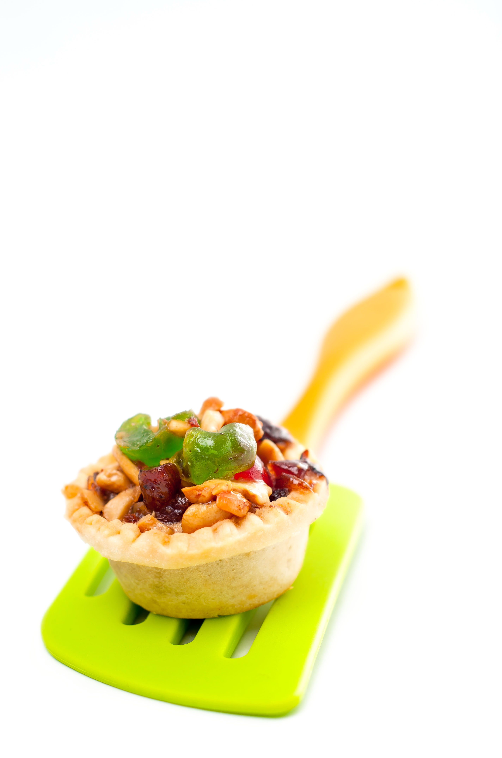

**Ingredients**

Milk Powder 1½ tablespoons

Fresh butter 56 g

Baking powder ½ teaspoon

granulated sugar 3 tablespoons

Salt 1¼ teaspoons

Egg 1 egg

Water 250 g

Cashew nut ½ cup

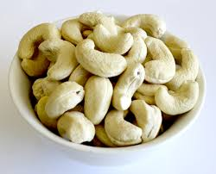

Maple syrup ½ cup

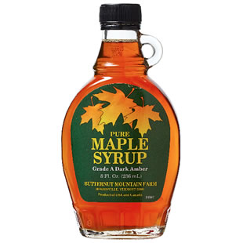

**Coconut Pie**

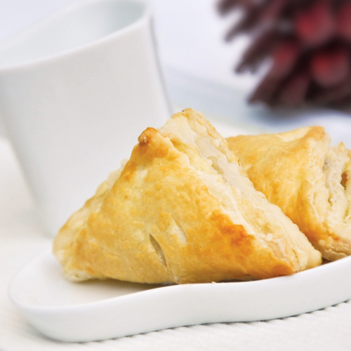

**Ingredients**

Coconut 2 cups

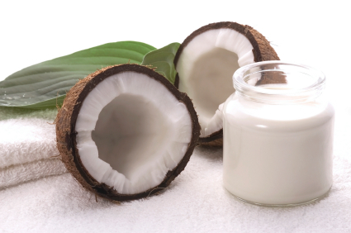

Shortening 4 tablespoons

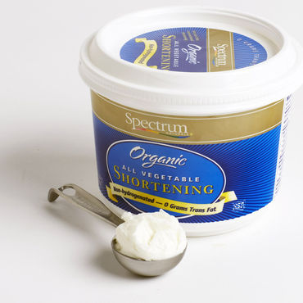

Lemonade 2 teaspoons

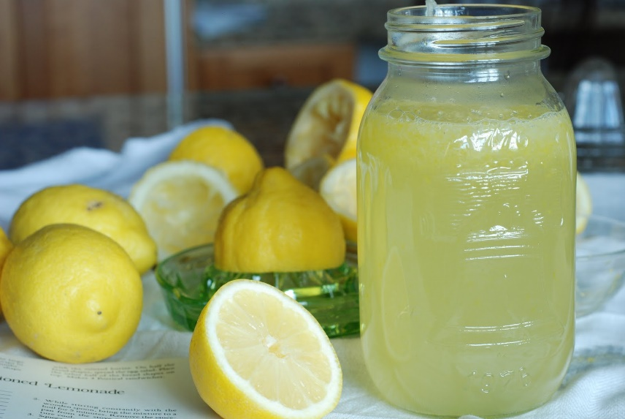

Water 56 g

Milk Powder 2½ tablespoons

Salt ½ teaspoon

Fresh butter 36 g

**Cookie**

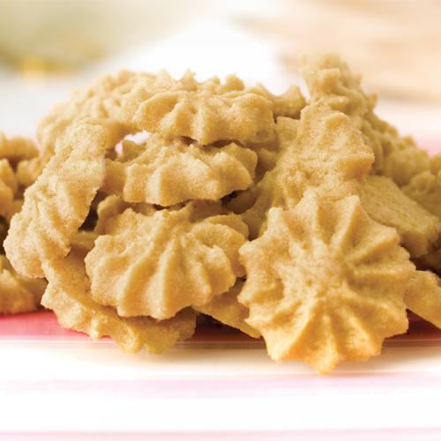

**Ingredients**

Cake flour 250 g

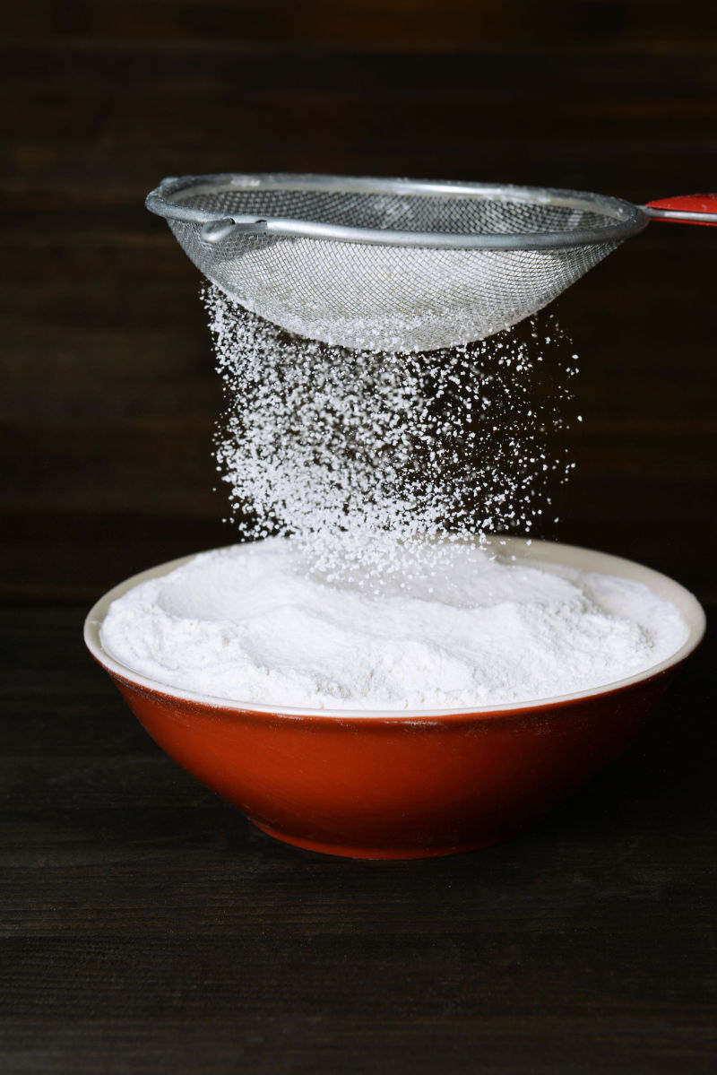

Icing sugar 125 g

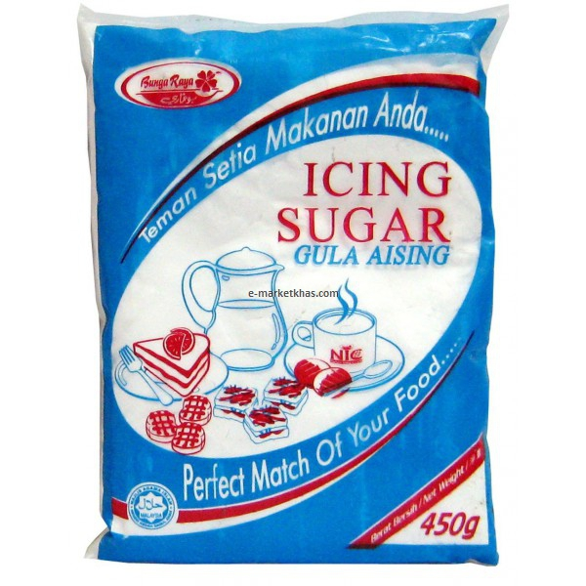

Egg 1 egg

Baking powder ¾ teaspoon

Fresh butter 125 g

Vanilla Powder 2 teaspoons

**Eclair**

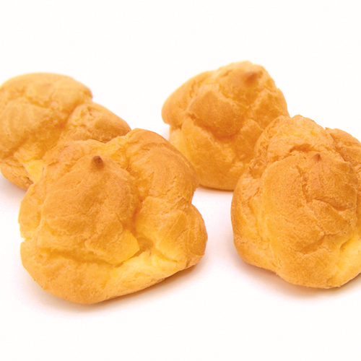

**Ingredients**

Corn flour 2¼ cups

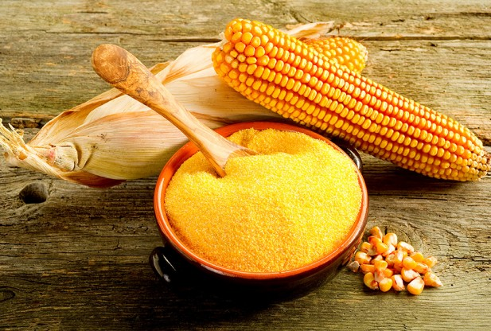

Yolk 4 eggs

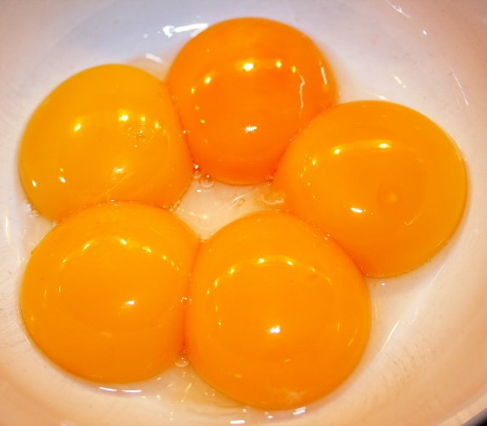

Fresh cream ¾ cup

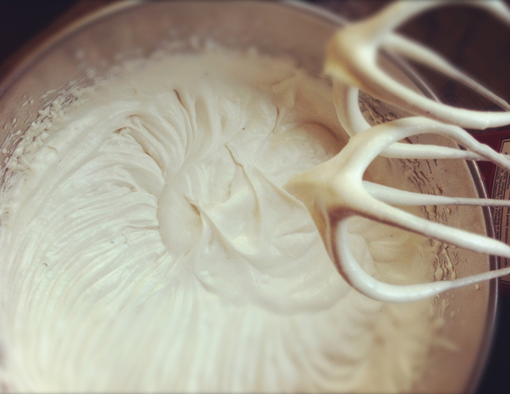

Water 112 g

Fresh butter 50 g

Milk Powder ½ tablespoon

granulated sugar ½ tablespoons

Vanilla Powder ½ teaspoon

Salt ¼ teaspoon

**Fresh Cream**

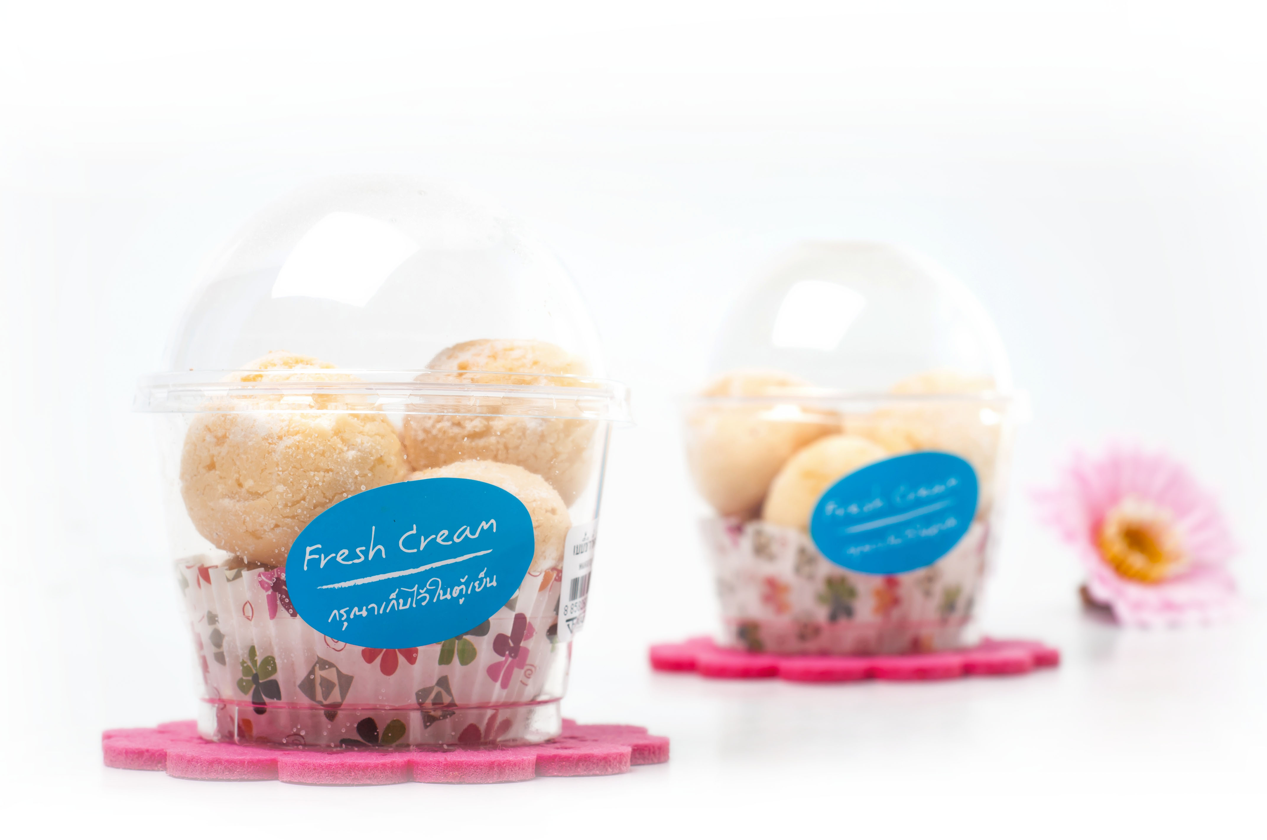

**Ingredients**

Fresh cream 10 cups

granulated sugar 10 tablespoons

**Fresh Milk Cake**

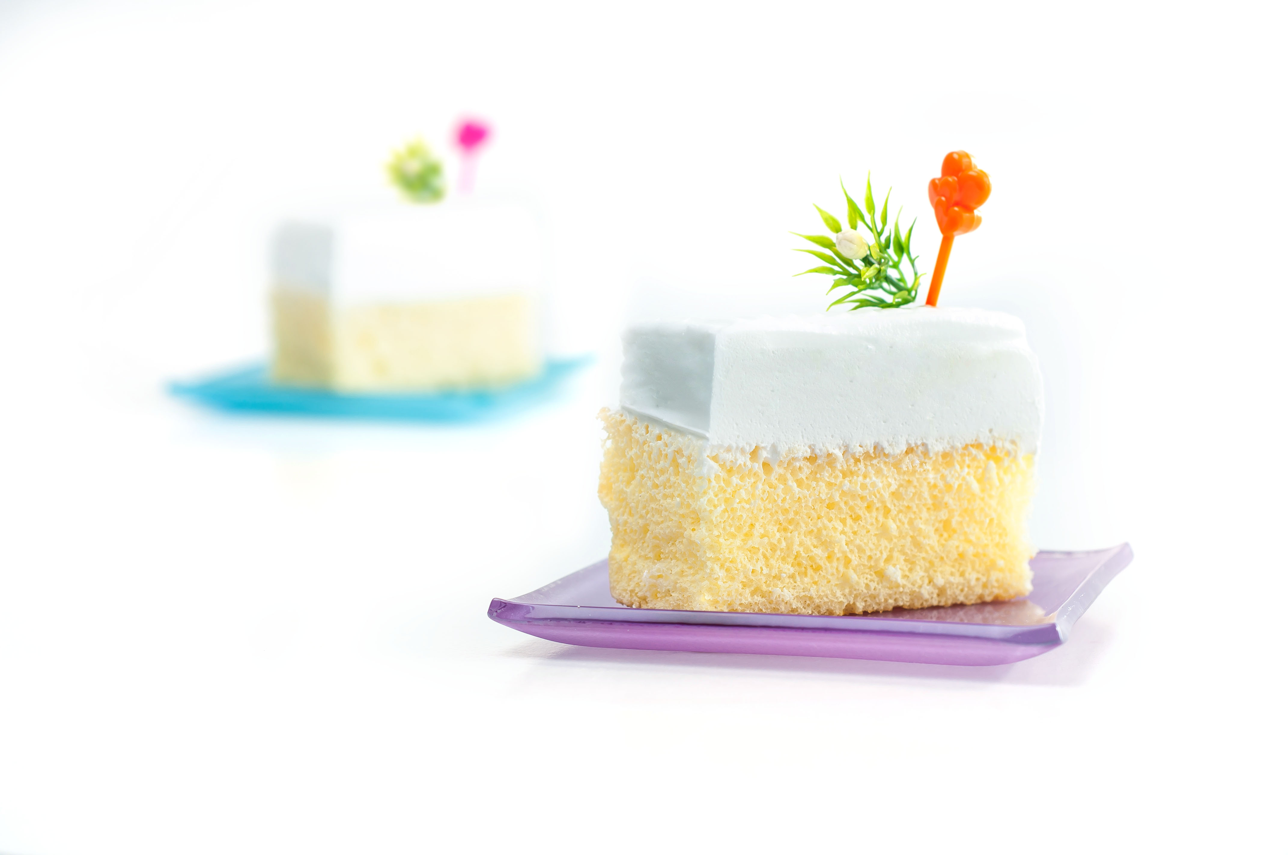

**Ingredients**

Cake flour 260 g

Vanilla Powder 1½ teaspoons

Baking powder 2¼ teaspoons

Egg 9 eggs

granulated sugar 13 tablespoons

Water 41 g

Fresh butter 240 g

Salt ½ teaspoon

Fresh milk 350 g

**Ham Sandwich**

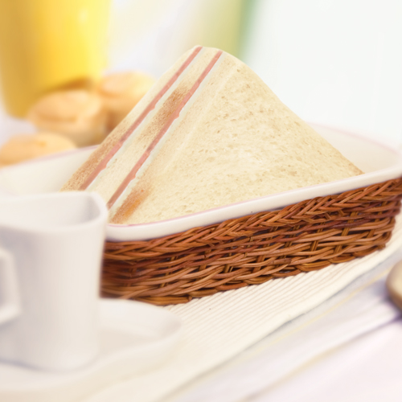

**Ingredients**

White bread 2 Pieces

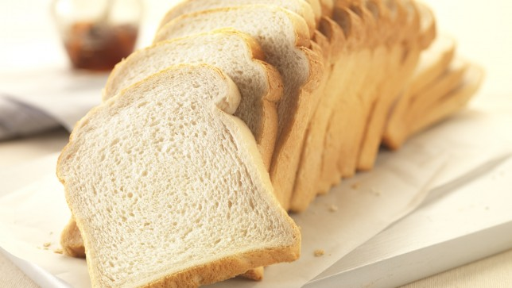

Cheese 1 piece

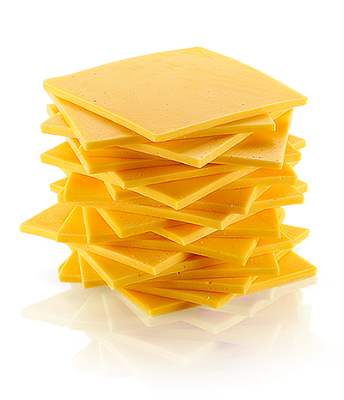

Ham 1 piece

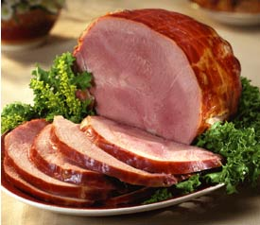

**Pieappple Pie**

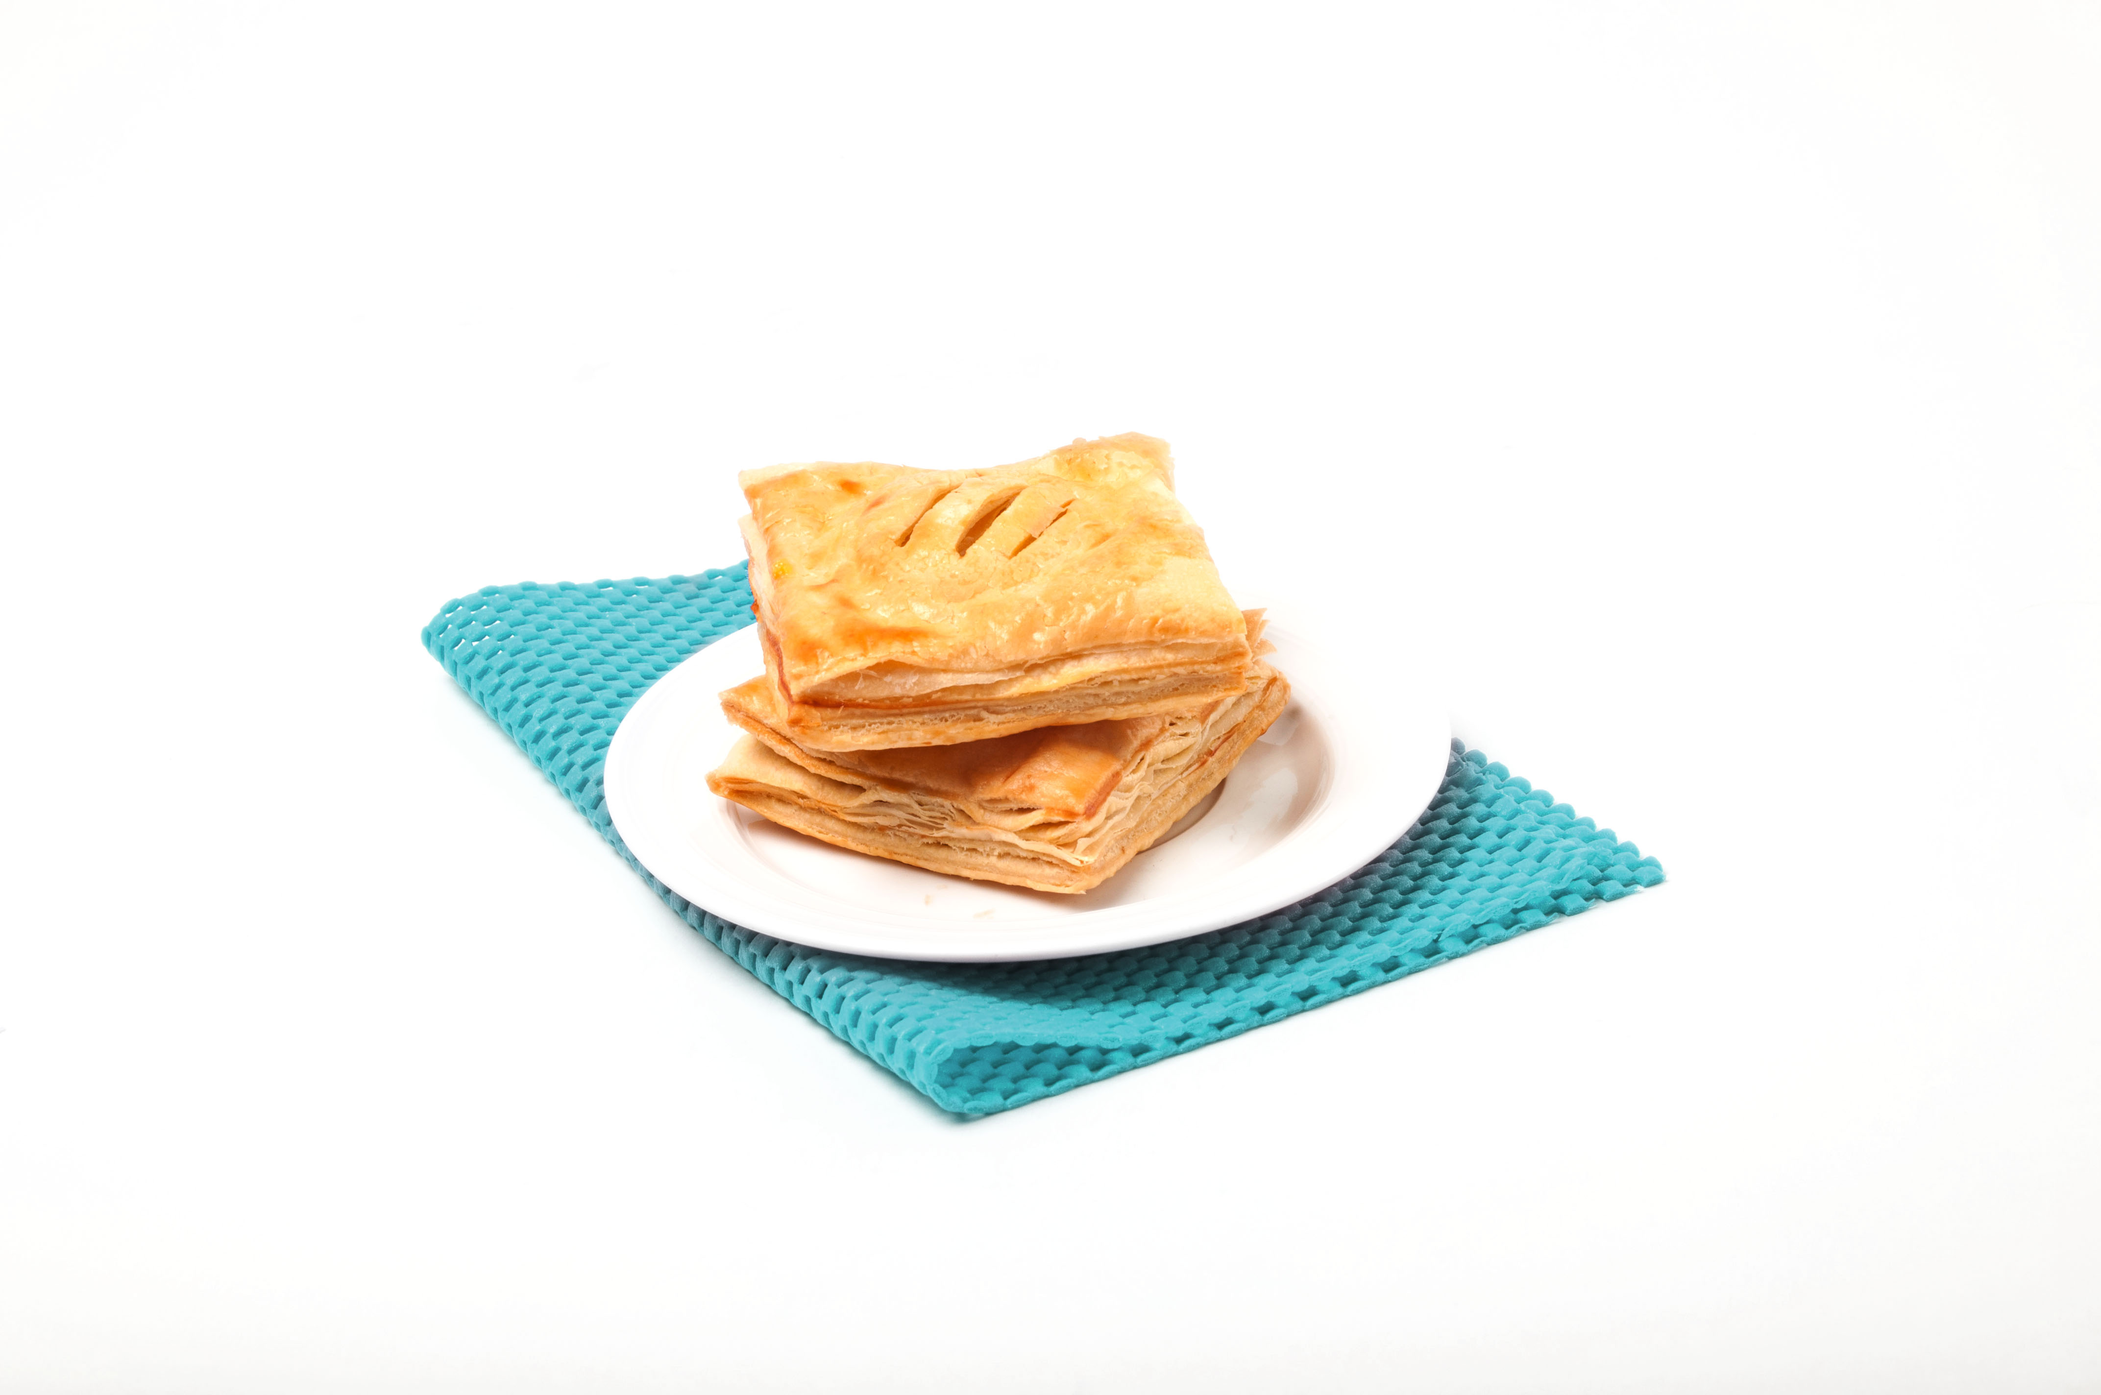

**Ingredients**

Pineapple 5 cups

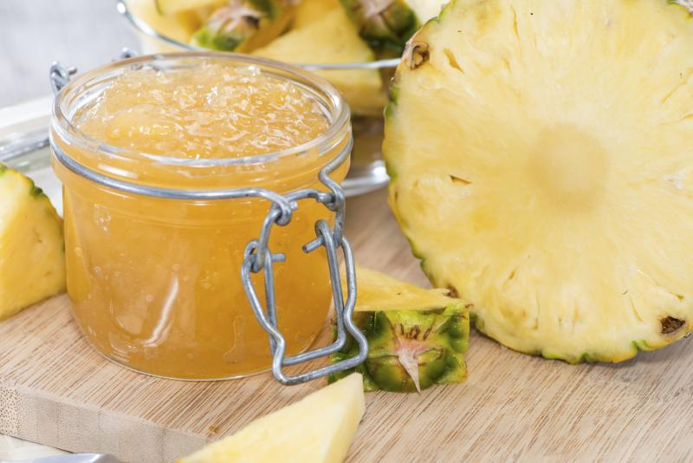

Salt ½ teaspoon

granulated sugar 1 ¼ tablespoons

Milk Powder 3 tablespoons

Baking powder 2 teaspoons

Fresh butter 180 g

Water 14 g

**Raisins & Nuts Tart**

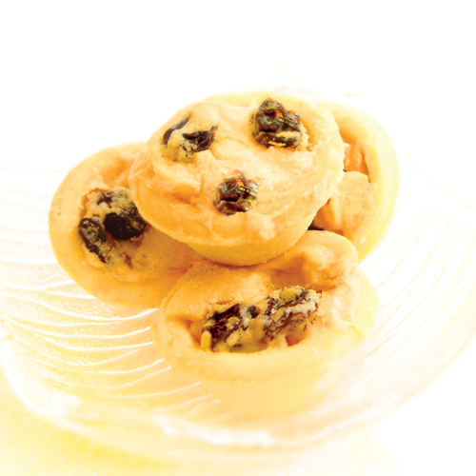

**Ingredients**

Milk Powder 1½ tablespoons

Fresh butter 56 g

Baking powder ½ teaspoon

granulated sugar 3 tablespoons

Salt 1¼ teaspoons

Egg 1 egg

Water 250 g

Maple syrup ½ cup

Raisin ½ cup

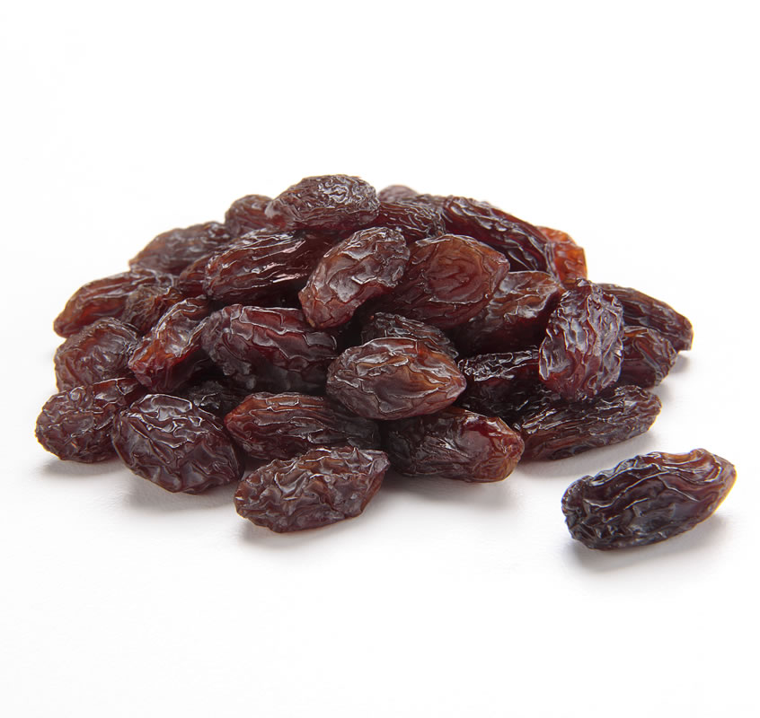

**Steamed Dried Pork Bun**

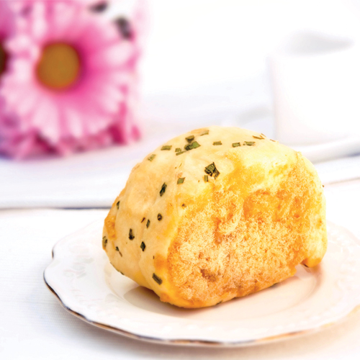

**Ingredients**

Dried pork 250 g

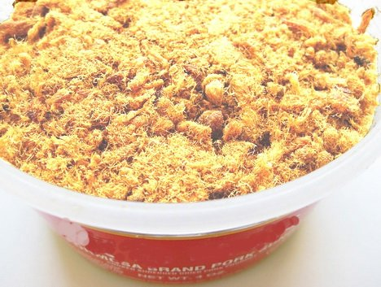

Egg 2 eggs

Bread flour 400 g

Fresh cream ½ cup

Fresh butter 13 g

Shortening ½ tablespoons

Milk Powder 2½ tablespoons

granulated sugar 3 tablespoons

Salt 2 teaspoons

Yeast 10 g